**Mono Setup**

1. **Install Mono for Windows 3.2.3**

C:\Program Files (x86)\Mono-3.2.3

1. **Setup environment variables**

MONO_BIN = C:\PROGRA~2\MONO-3~1.3\bin

MONO_HOME = C:\PROGRA~2\MONO-3~1.3

1. **Add it to Path**

C:\PROGRA~2\MONO-3~1.3\bin

C:\PROGRA~2\MONO-3~1.3\bin

1. **Setup include in Visual Studio**

$(MONO_HOME)\include\mono-2.0

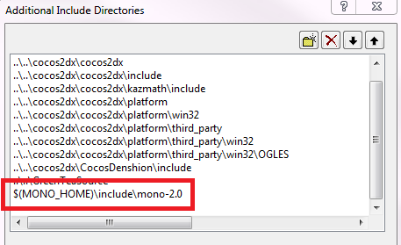

1. **Use include in source code**

#include<mono/jit/jit.h>

#include<mono/metadata/assembly.h>